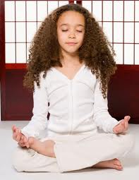
Top 10 Ways to COOL DOWN
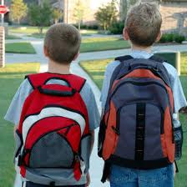
- Take 5 deep belly breaths.
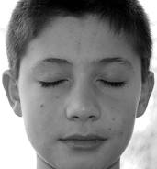
- Walk away.
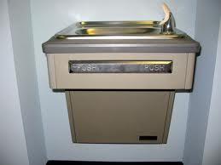
- Close your eyes. Count up to ten, count down from 10.
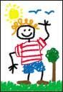
- Take a break. Get a drink of water or go to the bathroom.

- Distract yourself by cleaning your desk, drawing a picture, or reading a book.
- Imagine yourself in a happy or relaxing place.


- Fake a smile or imagine yourself laughing at a joke.
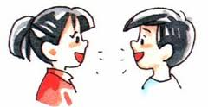
- Write a letter to tell someone how you feel, even if you don’t send it.
- Talk to someone you trust about what is bothering you.
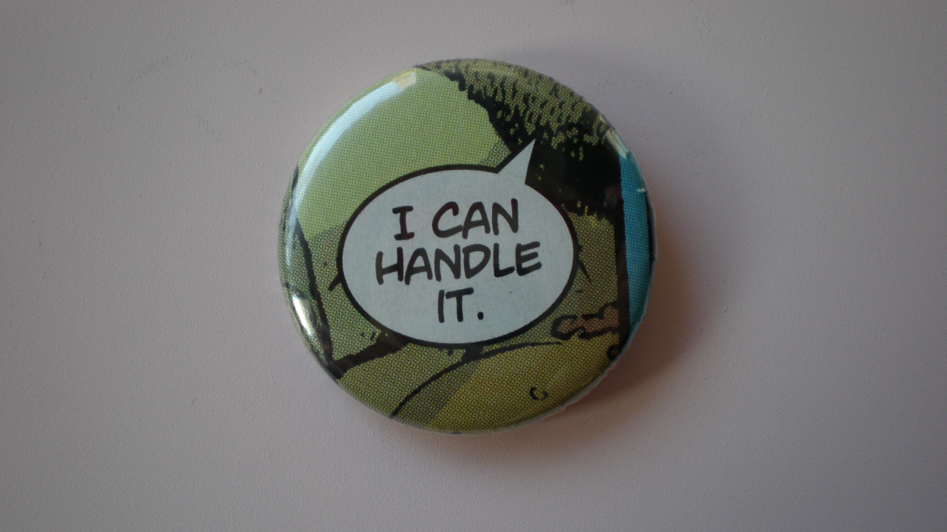
- Talk yourself into being calm: say, “Be calm, be calm” or “I can handle this”.

